Chemistry 2B
Practical Theory Test
Name: Solutions

Score: /18
Instructions to students: Complete on this paper, use of Lab report books allowed.

Part 1: Experiment 10

A student conducted an experiment to determine the empirical formula of calcium oxide. The student weighed a dried crucible and lid, reweighed the crucible and lid after adding a sample of calcium. The heated the calcium for 10 minutes before reweighing the crucible again. The measurements are recorded in the table below.

Mass of crucible and lid | 34.1 g
Mass of crucible, lid and calcium | 36.4 g
Mass of calcium | 2.3g g
Mass of crucible, lid and calcium oxide | 37.8 g
Mass of calcium oxide | 3.7g g
Mass of oxygen combined with calcium | 1.4g g

- Fill in the missing information in the table above. [1½]
- Using this data, determine the empirical formula of calcium oxide. [1½]

 | Calcium | Oxygen
Mass | 2.3 | 3.7
moles | 0.057 | 0.0875
Ratio | 1 (2) | 1.5 (3)

Ca₂O₃

Part 2: Experiment 13

Solutions containing known masses of lead nitrate and sodium iodide where combined to form a precipitate, which was then collected and dried.

- What the precipitate formed? [1]

Lead (II) iodide (PbI₂)

- Predict the mass of precipitate formed in the following [3]

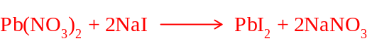

Mass Pb(NO₃)₂ | Mass NaI | Mass of precipitate
1.66g  n = 0.005 | 0.75 g  n = 0.005  limiting | 0.0025 moles produced  1.15g
1.66g  n = 0.005 | 1.35g  n = 0.009  limiting | 0.0045 moles produced  2.08 g
1.66g  n = 0.005  limiting | 2.10g  n = 0.014 | 0.005 moles produced  2.31 g

Part 3: Experiment 22

- Write ionic equations for the reactions between each of the following: [4]
    - hydrochloric acid and sodium hydroxide

    - hydrochloric acid and copper oxide

    - hydrochloric acid and calcium carbonate

    - sulphuric acid and sodium hydrogen carbonate

- Write an ionic equation that describes a successful limewater test. [1]

Part 4: Experiment 23

- Of the metals used in this experiment, which appeared to be the most reactive with acids? Explain your decision based upon your observations. [1]

Magnesium – appeared to have fastest reaction rate

- Of the metals used in this experiment, which appeared to be the least reactive with acids? Explain your decision based upon your observations. [1]

Copper – appeared to have slowest reaction rate

- Write an ionic equation for the reaction between any reactive metal and hydrochloric acid. [½]

For example: preferable to use Mg or Zn

- Write an ionic equation explaining the pop test. [½]

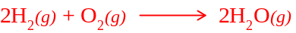

Part 5: Experiment 26

Write the oxidation and reduction half equations and the overall redox equation for the following: [3 marks]
(If there was no reaction, write ‘no reaction’)

- Chlorine water and KI solution -

Red: 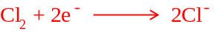

Ox: 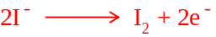 [½ mark for both half equations]

Overall: 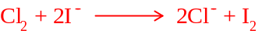 [½ mark for full equation]

- Bromine water and KI solution - note to teacher – there is a reaction

Red: 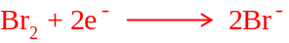

Ox:

Overall: 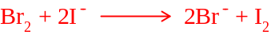

- Iodine water and KCl solution – note to teacher, no reaction

